# 

# **Template – Transcript Request Form**

The template named “Template – Transcript Request Form” is applicable to CampusNexus Student.

## Purpose and Outcome

This template provides a form sequence and supporting workflow for a transcript request to be submitted by a student. The sequence requires the following:

* A complete **Student record** must exist in the CampusNexus Student database.
* The student must have a **Portal login** to log into this authenticated sequence.
* The student must have a **credit card** to pay the fees associated with the transcript request.

The Forms Builder must support credit card payments using the PayPal or ACI payment gateways.

Upon completion of the sequence:

* A transcript is sent to the student, to another institution, or to a company.
* The transcript request is added to the student record.
* The transcript charge and payment are posted to the student’s ledger card.

The template simplifies a complete student self-service transcript request process as detailed in the **Transcript Request Form README STEP 2** document.

## Prerequisites

The template was built in Forms Builder using the applications listed below. The template is forward compatible with later versions of the listed applications.

|  |  |
| --- | --- |
| **Application** | **Minimum Version** |
| Forms Builder Designer and Renderer | 3.4 |
| Web Client for CampusNexus Student | 19.0 |
| Workflow Composer | 2.6 |
| Packages installed from Package Manager in Workflow Composer | Activities and Contracts (V1) 19.0.0  Activities and Contracts (V2) 19.0.0  Forms Builder Contracts 3.4 |
| Workflow Tracking Database | N/A |
| Staff STS 2.0 | 2.0 |

## Step 1: Download and Import the Template

1. Download the template file (xml) to your environment (local drive or network location).
2. Log into **Forms Builder Designer**.
3. Click the **Export/Import** tile.
4. Select the **Import** tab.
5. Click **Select exported file** and navigate to the downloaded template file (xml).
6. Click **Import**.

* [Export/Import](https://help.campusmanagement.com/FB/3.x/Content/ExportImport.htm)

### The following forms will be imported:

### End State - Transcript Request Form

### Transcript Request Form Company

### Transcript Request Form Institution

### Transcript Request Form Me

### Transcript Request Form Payment

### Transcript Request Form Step 1

## Step 2: In Form Designer…

1. From the **Forms** slide out, select the **Transcript Request Form Step 1**.
2. Customize the form for your environment. Modify properties on current fields to make them required, etc., or add/remove fields on form.

Make sure you edit the text in the Labels and HTML controls as applicable for your institution.

* [Fields](https://help.campusmanagement.com/FB/3.x/Content/Fields.htm) and [Components](https://help.campusmanagement.com/FB/3.x/Content/Components.htm)

1. **Save** the form.
2. Repeat steps 1-3 for the following forms:

### **End State – Transcript Request Form**

### **Transcript Request Form Company**

### **Transcript Request Form Institution**

### **Transcript Request Form Me**

### **Transcript Request Form Payment**

1. Navigate to the **Settings** workspace in Forms Builder and check the **Payment** settings.

The imported sequence uses the VerifyCardPayment activity to process payments using the ACI or PayPal payment gateways. The activity does not support IATS payments. Ensure that your ACI or PayPal settings in Forms Builder are correct and complete.

## Step 3: In Sequence Designer…

1. Select the Transcript Request Form **Sequence**.

The sequence contains the following forms in the following order:

### Transcript request Form Step 1

### Transcript Request Form Me

### Transcript Request Form Institution

### Transcript Request Form Company

### Transcript Request Form Payment

The End State – Transcript Request Form is selected as the End State Forms for the sequence.

1. Click **Save As** to create a copy of the sequence/workflow and customize the copy for your use. This way you can always refer to the original sequence/workflow you downloaded.
2. Optional - Add a custom style (theme) associated with your campus.

* [Themes](https://help.campusmanagement.com/FB/3.x/Content/Themes.htm)

1. Select your sequence in the Sequences pane.
2. In the Properties Pane:
   * Ensure that the **Authentication Product** is **Student**.

* Select the **End State Form** named “End State – Transcript Request Form”.

1. **Save** the sequence**.**
2. Open the associated sequence workflow.

Depending on your environment, to open Workflow Composer either click **Open Workflow** in Sequence Designer or launch of a local installation of Workflow Composer.

* [Opening Workflows for Sequences](https://help.campusmanagement.com/FB/3.x/Content/HostedEnv.htm)

## Step 4: In Workflow Composer…

1. Double-click the first form/state of the workflow named “Transcript” and locate the Assign activity named “Assign Transcript Amount”.

Update the hard-coded **depositEntity.Amount** value of 7.00d as appropriate for your environment.

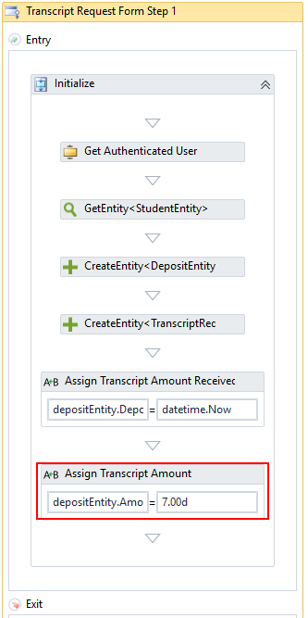

1. Double-click the **Continue** transition towards the end of the workflow and locate the **CreateCharge** activity.

Select a **Charge Code** as appropriate for your environment.

Update the hard-coded **Amount** value of 7.00d as appropriate.

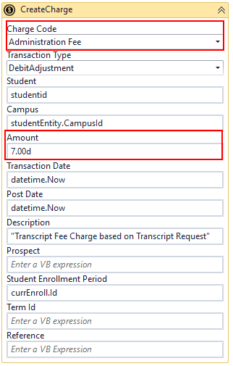

* [Create Charge activity](https://help.campusmanagement.com/WF/Content/Workflow/CreateChargenew.htm)

1. If Cash Drawer Sessions are used at your campus, locate the **Send to Student Accounts** sequence further down in the Continue transition and add assignments for the following values:

* CashDrawerId
* CashDrawerSessionId
* CashierId

## Step 5: In Forms Renderer and CampusNexus Student…

Select your sequence and try it out!

* [Sequence List](https://help.campusmanagement.com/FB/3.x/Content/SequenceList.htm)

1. Find your **Transcript Request Form Sequence** and copy the **URL** to the clipboard.
2. Log in to Portal as a **student** and complete the form sequence.
3. In CampusNexus Student:

* Verify that the transcript request was added for the student.
* Verify that the student's transcript charge and payment posted to the ledger.

## Step 6: Lastly…

Once your updated sequence has been tested successfully, it is recommended that you disable the workflow for the original Template version.

1. In Workflow Composer, in the Server section of the ribbon, click **Open**.
2. Find the workflow named “**Transcript Request Form Sequence**”.
3. Clear the **Enabled** check box and click **Save**.